Newsletter Topics

The veterinarians and staff at the Antioch Animal Hospital are pleased to provide you with an online newsletter.

Here you will find interesting updates about our hospital as well as articles pertaining to pet care, updates about our hospital as well as some latest trends and discoveries in our field.

This fun and fact-filled newsletter will be updated on a regular basis.

Please enjoy the newsletter! 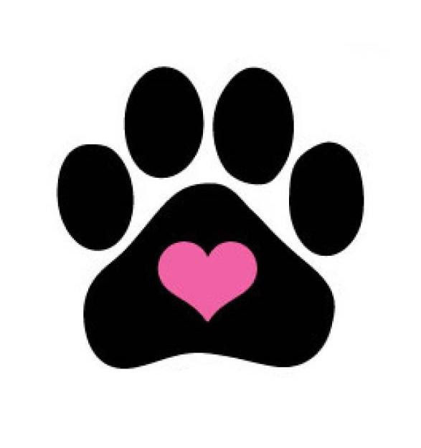

**Volume 1, Issue 1**

**October Newsletter**

**Antioch Animal Hospital**

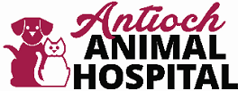

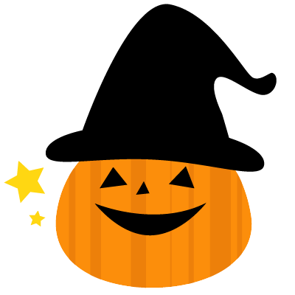



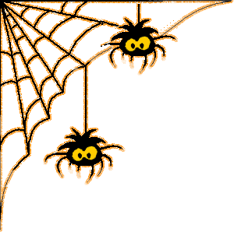

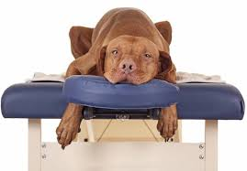

We now offer

Veterinary Spinal Manipulative Therapy (chiropractic)

Stay tuned for more info…

**DENTAL MONTH**

**COMING UP IN NOVEMBER!!!**

**ASK A STAFF MEMBER FOR MORE INFORMATION**

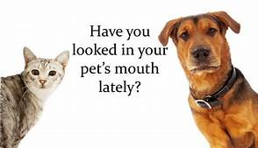

**Want to see your pet featured in our upcoming newsletters?**

Submit your favorite pet picture for a chance to see them in our monthly newsletter!

Each month we will feature as many pets as we can. Don‘t forget to include your pet’s name!

You can bring them by and turn them in to our front desk staff or mail them in. Please make sure you label it “Newsletter pet photo”

Halloween is coming up so show us your best Halloween pet picture!

**Your Pet’s Dental Health.**

Dental disease is one of the most commonly diagnosed problems during your pet’s physical exam.

Your veterinarian will discuss with you the options for your pet after a thorough evaluation of his or her mouth.

At Antioch Animal Hospital, maintaining your pet’s oral health is one of our most important goals. Please take advantage of special offers for dental prophylactic cleaning in the month of November.

Stages of periodontal disease:

**Stage 1 Gingivitis.** It is the inflammation of the gum caused by formation of plaque (film of bacteria). If not addressed early, gingivitis can lead to further progression of gum disease.

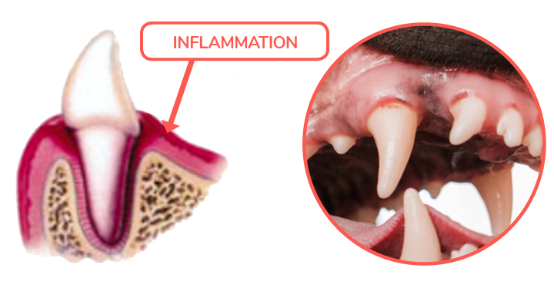

**Stage 2 Tartar.** Bacteria continue to multiply and migrate into the sulcus (narrow space surrounding root of the tooth). Plaque starts interacting with minerals in your pet’s mouth at which point, the film begins to harden and tartar forms. Once inflammation progresses, tartar will move from the tooth below the gum surface. At this point, you may notice red gums and smell bad mouth odor.

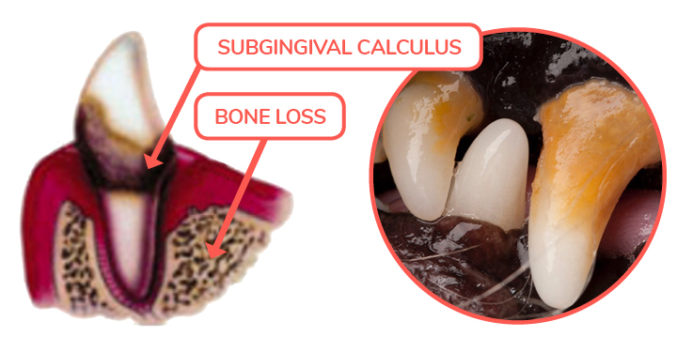

**Stage 3 Periodontal disease.** Due to progressive infection, bone loss may follow. This is associated with pain, tooth mobility and eventual tooth loss. Some pets may even have difficulty eating.

Inflammation and bone disease will expose bacteria to the blood stream where they can travel throughout the whole body consequently impact your pet’s kidneys, liver, and even heart.

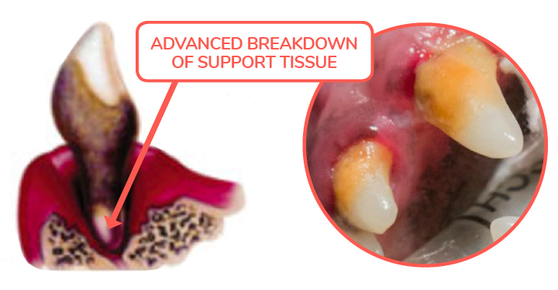

Pictures from Dogs Naturally magazine

Pet owners do not routinely examine their pet’s mouth, therefore many times they are very surprised when they are informed by a veterinary professionals about the dental disease their pet has. Routine annual exams will help bring any issues to light.

**There are many helpful suggestions that your veterinarian will discuss during your visit. Here are some of them:**

1. **Brushing:** Daily brushing with small, soft tooth brush and specialized animal tooth paste may keep your pet’s mouth healthy and delay dental cleanings
2. **Prophylactic cleaning :** Your veterinarian may recommend dental prophylactic cleaning which is done under anesthesia. It only takes about 30 to 45 minutes during which your pet’s teeth are fully evaluated for gingivitis and periodontal disease. Teeth are thoroughly cleaned with ultrasonic scaler and polished. OraVet gel is applied which prevents immediate plaque formation. If any gingivitis is noted and gingival pockets found, topical antibiotic treatment may by conducted. Depending on the age and the breed of your pet, those cleanings may be recommended yearly to every few years.
3. **Oral wash:** You veterinarian will recommend mouth rinse or water additive which will decrease number of bacteria in oral cavity.
4. **Special diet:** You veterinarian may also recommend dental diet, either as a main diet fed or as an additive, depending on the need of a specific patient.
5. **Dental treats:** Your veterinary professional will recommend treats or chew that should be offered to your pet to continue promoting dental health.

**In attempt to help our clients and their pets to maintain good dental health, Antioch Animal Hospital offers multiple discounts:**

* November is our dental month. During the whole month of November, we offer **15% discount** on dental cleaning to all of our clients.
* Remember, if your veterinarian recommends a dental prophylactic cleaning and you schedule the procedure within 30 days of your visit, you will receive **10% discount**. This offer is valid every month.
* We also offer **10% multi-pet discount** valid every month.
* All discounts are additive!

# https://www.hillspet.com/content/dam/cp-sites/hills/hills-pet/global/articles/general/logo-transforming-lives.png How to Keep Your Dog Safe on Halloween

There are few things in life cuter than seeing your terror-of-a-puppy dressed up in horns and a red cape on Halloween. But for dogs and their families, Halloween should also be a time for caution. To ensure that both your children and dogs enjoy a fun and safe holiday, please remember the following tips:

* Your dog can easily become anxious and frightened when the doorbell is constantly ringing and all he sees are children in strange clothes and masks. Confining him to his own safe haven for the evening (like his crate or a closed room) can help calm his nerves and prevent him from running out of the constantly opening front door.
* If you walk your dog around the neighborhood while children are trick-or-treating, be sure to use a sturdy collar, or harness and leash, and be careful around unfamiliar children and adults. Again, the costumes and masks may make your dog uncomfortable and frightened.
* Be sure your dog is wearing identification tags with your name and phone number on them in case you become separated from your dog or he escapes from the house.
* If you're dressing your dog for Halloween, use safe, non-flammable and non-toxic items that your dog is comfortable in and that don't restrict his movement, breathing or vision.
* Lastly, keep all candy out of your dog's reach — especially [chocolate](https://www.hillspet.com/dog-care/nutrition-feeding/is-chocolate-bad-for-dogs), which is toxic to dogs. Consumption of even small amounts can cause seizures, muscle tremors and vomiting while larger doses can be fatal. [Stick to his own treats](https://www.hillspet.com/dog-care/nutrition-feeding/giving-your-dog-treats) and he'll be just as happy.

**How to Make Your Cat Feel Safe on Halloween**

* Your cat can easily become anxious and frightened when the doorbell is constantly ringing and all she sees are children in strange clothes and masks. Confining her to her own safe haven for the evening (like a pet carrier or a closed room) can help calm her nerves and keep her from running out of the constantly opening front door.
* If you're dressing your cat for Halloween, use safe, non-flammable and non-toxic items that your cat is comfortable in and that don't restrict movement, breathing or vision.
* It’s best to keep cats indoors on Halloween, especially black cats. Many black cats end up missing on this night because of pranks or for other unspeakable reasons. It's better to be safe than sorry.
* Lastly, keep all candy out of your cat's reach — especially chocolate, which is toxic to cats.
* If you want to make [homemade treats](https://www.hillspet.com/cat-care/nutrition-feeding/healthy-homemade-cat-treats) for your cat, try this recipe.

Following these simple tips will help keep your dog and cat safe, healthy and out of any scary trouble this Halloween.

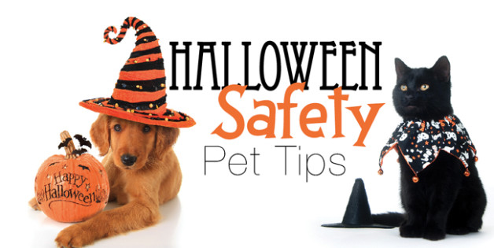

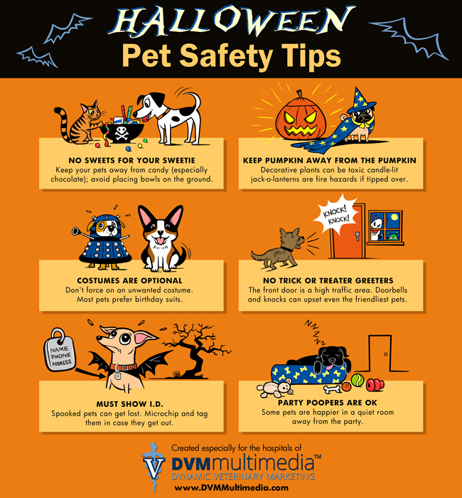

**From all of us at Antioch Animal Hospital, we wish you and your furry family members a safe and happy Halloween!!** 

